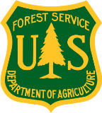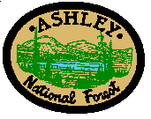
PONDEROSA PINE FORESTS
Fire Ecology and Forest Management
Ponderosa pine forests are adapted to frequent fire. The average natural fire return interval in the ponderosa pine forests on the Flaming Gorge Ranger District of the Ashley National Forest is around 20 years. The thick bark of mature ponderosa pine trees allows most of them to survive and thrive with frequent surface fire, which keeps forests healthy by reducing fuels and creating a mosaic of vegetative structures and habitats that allow for more plant and wildlife species diversity within a landscape.
In the absence of frequent fire, fuel build-up results in high-intensity, more severe wildfires that can result in high levels of mortality across entire ponderosa pine stands.
Managing natural fires for resource benefit and conducting prescribed burns at regular intervals benefit ponderosa pine ecosystems and create healthier, more resilient forests.
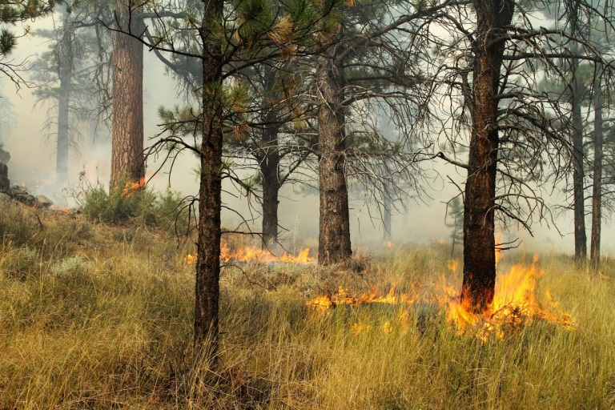
Photo: Lesley Tullis
For more information, contact:
ASHLEY NATIONAL FOREST
435-789-1181
355 North Vernal Avenue
Vernal, UT 84078
www.fs.usda.gov/ashley

